Developer Install Instructions

Section 1:

Installing Unity

1. Go to <https://unity3d.com/>
2. Click → Get Unity at the top

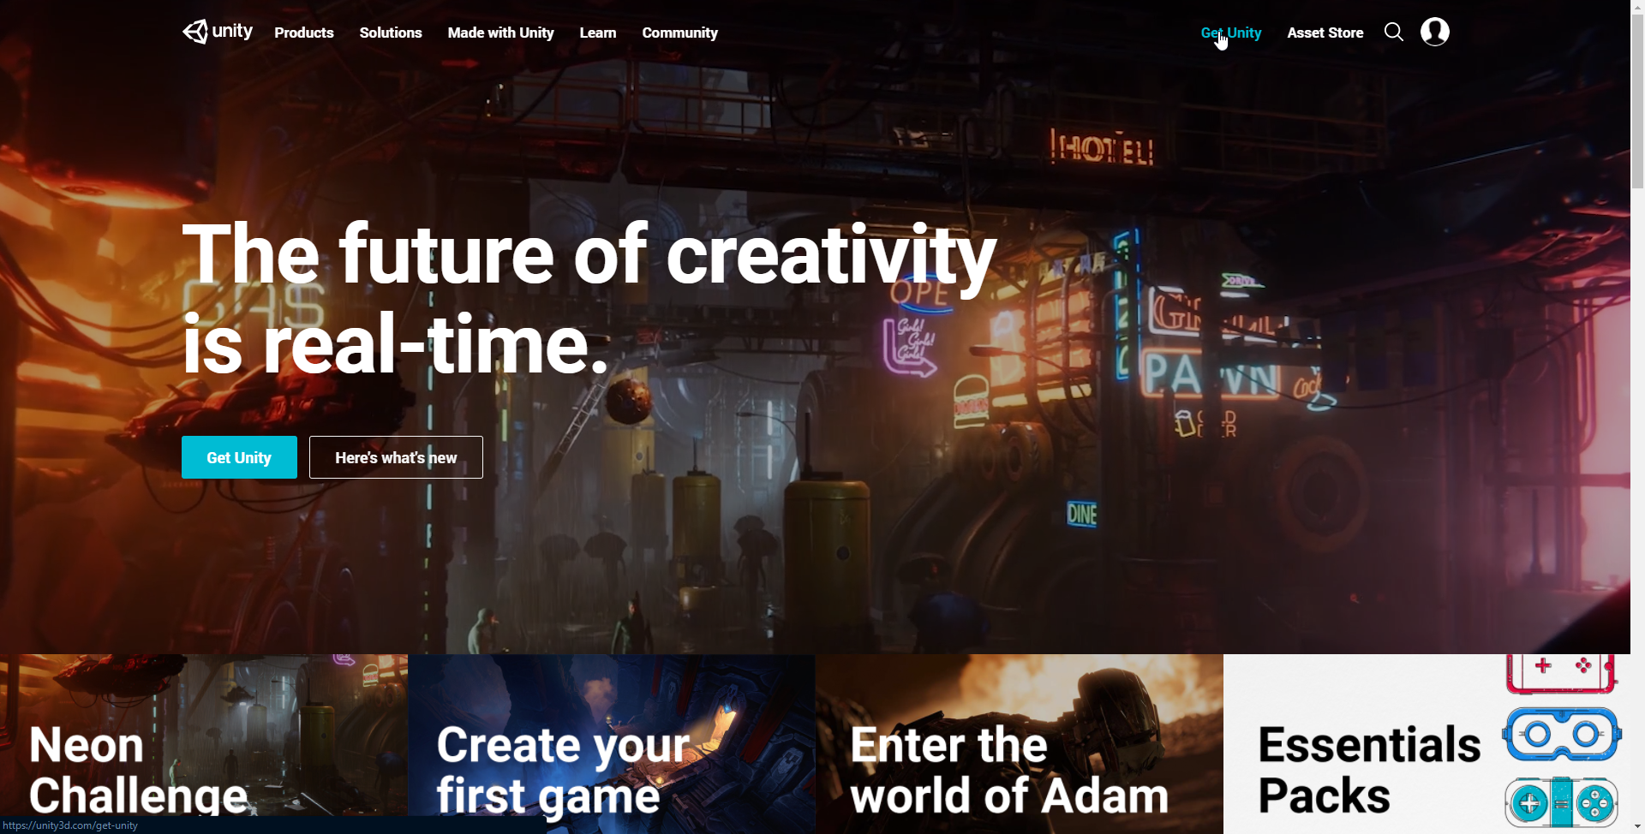

3. Choose Free version 🡪 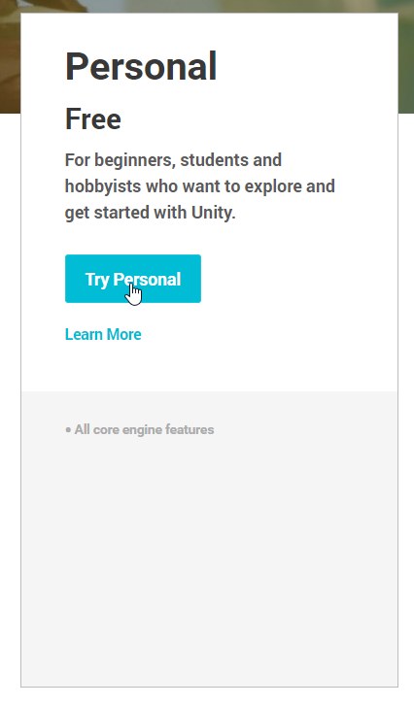

4. After reading and understanding the license and Terms of Service. 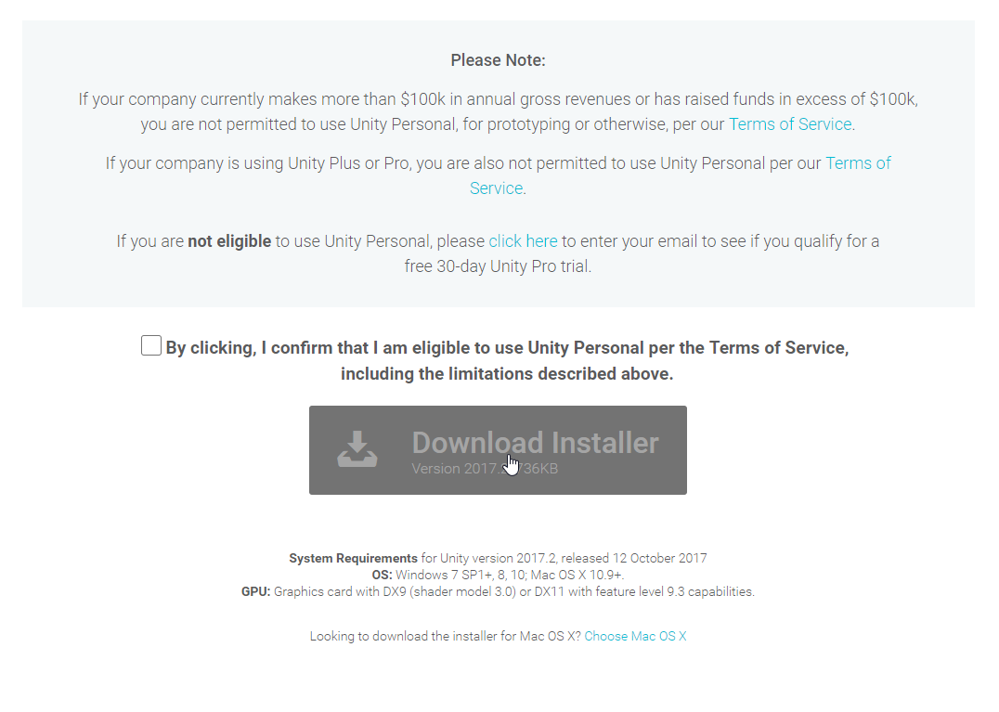

5. Sign up with your GGC email and password to get student benefits.

6. After you are in the unity development environment proceed to Next Section.

Section 2:

Unity

I made a video explaining all the different parts of the unity UI and all the scripts and the systems and how they all interact. I’ll also link some useful tutorials that I used as well to help below.

My Video: <https://www.youtube.com/watch?v=FGGvWWz7Dio>

Section 3:  
Other Useful Tutorials

Unity3D YouTube Channel: <https://www.youtube.com/user/Unity3D/videos>

Door tutorial : <https://www.youtube.com/watch?v=iKWJBgFCDWU>  
Animation tutorial: <https://www.youtube.com/watch?v=G4Ja-asl8hQ>